Hide Keyboard and ScrollView

1. Create new Swift Project
   1. Single View
   2. iPhone  
      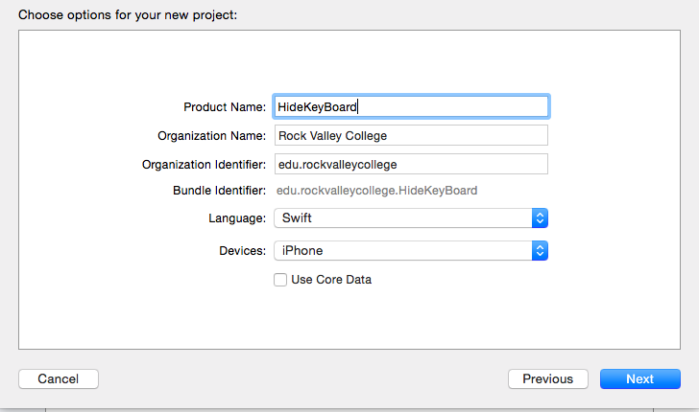
2. Make portrait Only  
   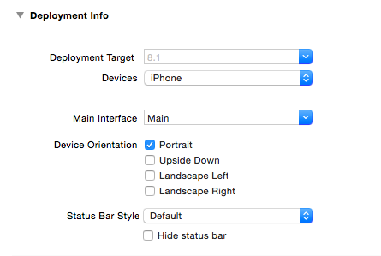
3. Add UILabel and Type “My Contacts” for Text property
   1. Click on Main.Storyboard
   2. Top of View
   3. Center Alignment   
      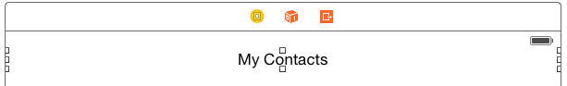
4. Add 3 UITextFields
   1. Add 1 UITextField and make width 195 (use size inspector)
   2. Center below “My Contacts label
   3. Duplicate UITextField twice with [Command] + D and stack
   4. Text Properties = [Empty]
   5. Placeholder Properties
      1. First Name
      2. Last Name
      3. Email   
         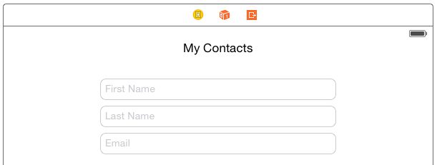
5. Add 2 UIButtins
   1. First Button – below and align left side of email UITextField
      1. Text Property: View Contacts
      2. Make wide enough to fit text by dragging selection boxes
      3. Align
   2. Second Button – below and align right side of email UITextField
      1. Text Property: Save
      2. Align  
         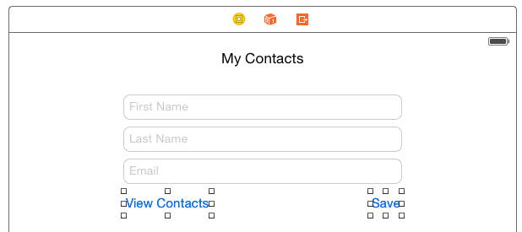
6. Select All Except Top Label. (Click and drag with mouse to select all objects)  
   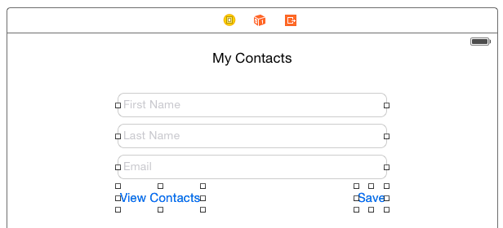
7. Embed in ScrollView
   1. With all objects selected except label (from last step)
   2. Go to: Editor > Embed In > ScrollView  
      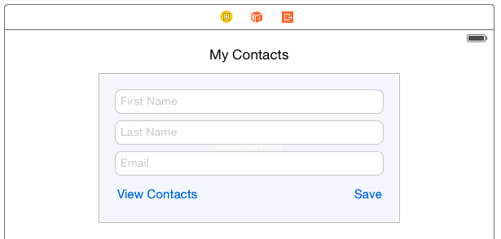
8. Change Width & Height of ScrollView using Size Inspector
   1. Width= 568
   2. Height = 900
   3. Select each object inside ScrollView with [Command] + Click
   4. Drag to center and align  
      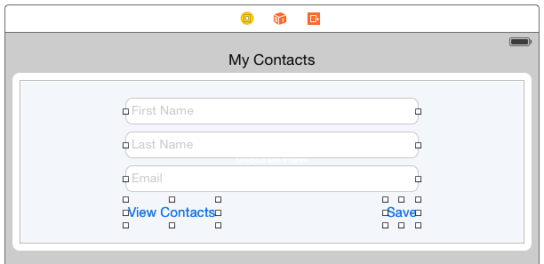
9. Click away from scrollview then click and drag up to bring bottom of scrollview into view  
   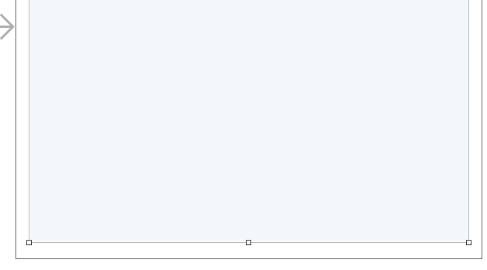
10. Add Button and UITextView as Below to bottom of ScrollView
    1. Double click and delete text in UITextView
    2. Text Property of UIButton: Back
    3. Width: 433 Height: 200  
       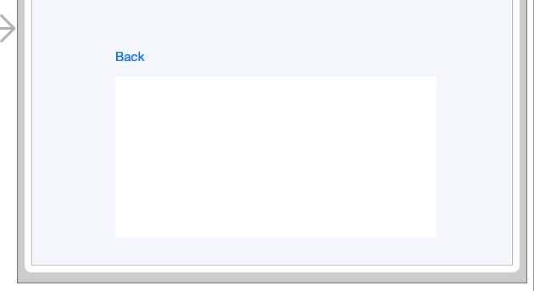
11. 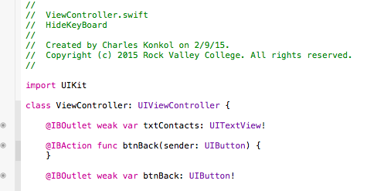Create Action/Outlets
    1. Back UIButton
       1. Name: btnBack
       2. Create Action with UIButton
          1. Type: UiButton
       3. Create Outlet with UIButton
    2. UITextView
       1. Name: txtContacts
       2. Create Outlet

1. Click and Drag UIScrollView to view top of UIScrollView
2. Create Action/Outlets
   1. ScrollView
      1. Name: ScrollView
      2. Create Outlet
   2. First Name UITextField
      1. Name: txtFirst
      2. Create Outlet
   3. Last Name UITextField
      1. Name: txtLast
      2. Create Outlet
   4. Save UIButtin
      1. Name: btnSave
      2. Type: UiButton
      3. Create Action
   5. View Contacts UIButtin
      1. Name: btnView
      2. Type: UiButton
      3. Create Action
3. Click on ViewController.Swift and your code should look something like this  
   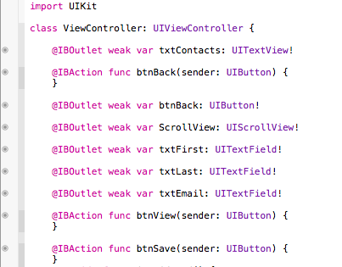
4. See [code for steps.txt](https://github.com/ioscourse/Week-5-HideKeyBoard---START/blob/master/code%20for%20steps.txt)
5. Add Delegate to UITextFields
   1. Select Main.Storyboard
   2. Select View Controller from Outline View
   3. Show Connections Inspector
   4. Click + Drag Referencing Outlets into textfield then release and select delegate  
      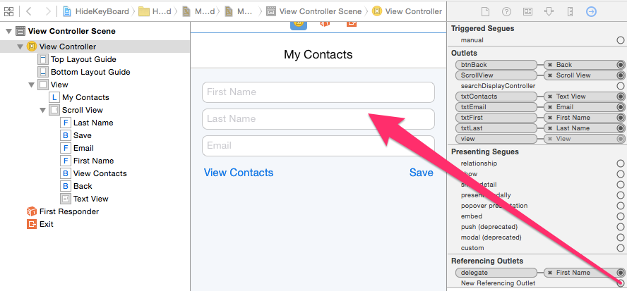
6. Align
   1. Select Top UILabel
   2. [Command] click scrollview
   3. Editor > Resolve Auto Layout Issues > Reset to Suggested Constraints (Top one)
7. Run App using iPhone 5s
8. Add code from example